Need to have &ttl_pages variable as total page counter because of external dfa ESTMT_IDX_WRITE_AFTER.dfa

Need to set ZIPFILE( or any name)

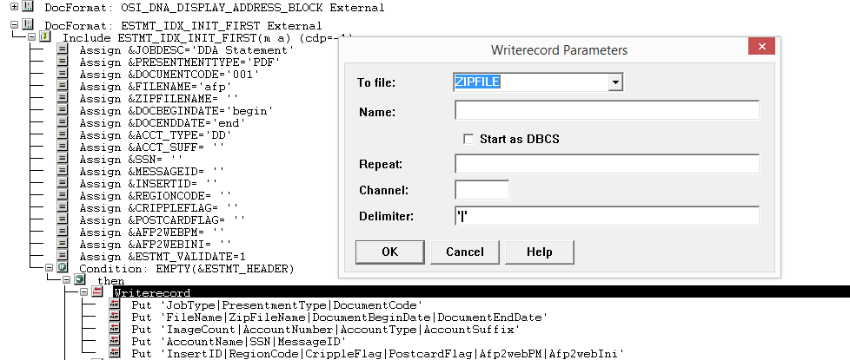

Formatgroup: (ZIPFILE configuration)

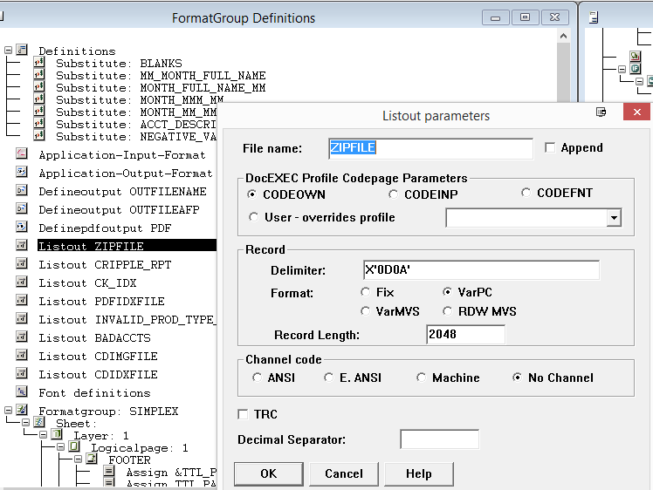

ZIPFILE set this as Environment Variable and gives a value( This value will be the output file for ‘f’ option)

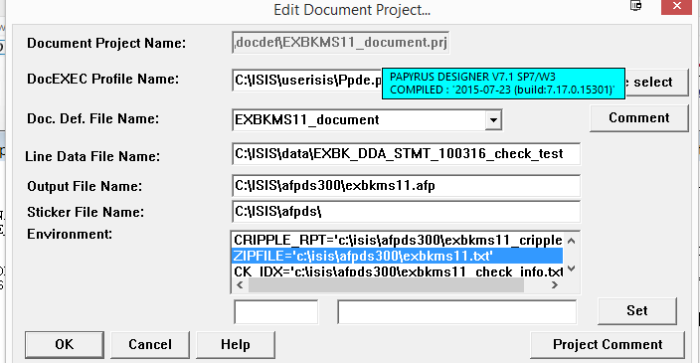

**In Beforefirstdoc:**

**/*need to declare individual afp path*/**

**/************Steps for New E Index***********/**

**IF $SYSTEM=='Windows' ;**

**THEN ;**

**&PATH_SLASH = '\' ;**

**&INDIV_PATH = 'c:\isis\afpds\' ;**

**ELSE ;**

**&PATH_SLASH = '/' ;**

**&INDIV_PATH = '/'!&D_DIR!'/'!&CID!'/'!&PREFIX!'-indiv/' ;**

**ENDIF ;**

**&ZIPFILE = ENVIRONMENT('ZIPFILE') ;**

**IF &JOB_TYPE=='f' ;**

**THEN ;**

**USE**

**FORMAT ESTMT_IDX_INIT_FIRST EXTERNAL ;**

**/*above is an external dfa where all variables needed for estatements are initialized we need to change some value according to particular project in internal docformat*/**

**ENDIF ;**

**ESTMT_IDX_INIT_FIRST.dfa**(do not need to copy )

**&JOBDESC = 'DDA Statement' ;**

**&PRESENTMENTTYPE = 'PDF' ;**

**&DOCUMENTCODE = '001' ;**

**&FILENAME = 'afp' ;**

**&ZIPFILENAME = '' ;**

**&DOCBEGINDATE = 'begin' ;**

**&DOCENDDATE = 'end' ;**

**&ACCT_TYPE = 'DD' ;**

**&ACCT_SUFF = '' ;**

**&SSN = '' ;**

**&MESSAGEID = '' ;**

**&INSERTID = '' ;**

**&REGIONCODE = '' ;**

**&CRIPPLEFLAG = '' ;**

**&POSTCARDFLAG = '' ;**

**&AFP2WEBPM = '' ;**

**&AFP2WEBINI = '' ;**

**&ESTMT_VALIDATE = 1 ;**

**IF EMPTY(&ESTMT_HEADER) ;**

**THEN ;**

**WRITERECORD TO ZIPFILE**

**DELIMITER '|' ;**

**PUT 'JobType|PresentmentType|DocumentCode' DELIMITED ;**

**PUT 'FileName|ZipFileName|DocumentBeginDate|DocumentEndDate'**

**DELIMITED ;**

**PUT 'ImageCount|AccountNumber|AccountType|AccountSuffix'**

**DELIMITED ;**

**PUT 'AccountName|SSN|MessageID' DELIMITED ;**

**PUT 'InsertID|RegionCode|CrippleFlag|PostcardFlag|Afp2webPM|Afp2w'**

**'ebIni' START *;**

**ENDIO;**

**&ESTMT_HEADER = 1 ;**

**ENDIF ;**

**In printdoc:**

**/*need to implement this step before printing anything**

**reassign appropriate value to variables of ESTMT_IDX_INIT_FIRST external dfa as per project and create individual**

**afp*/**

**/************Steps for New E Index***********/**

**IF &JOB_TYPE=='f' ;**

**THEN ;**

**:ASSIGNING_VARIABLES ;**

**/*should not contain any sign inside date*/**

**&DOCBEGINDATE = CHANGE(CHANGE(STMT_BEG_DATE,'-', ''),'/', '') ;**

**&DOCBEGINDATE = SUBSTR(&DOCBEGINDATE,5,4, '')!**

**SUBSTR(&DOCBEGINDATE,1,2, '')!SUBSTR(&DOCBEGINDATE,3,2, '') ;**

**&DOCENDDATE = CHANGE(CHANGE(STMT_END_DATE,'-', ''),'/', '') ;**

**&DOCENDDATE = SUBSTR(&DOCENDDATE,5,4, '')!SUBSTR(&DOCENDDATE,1,2,**

**'')!SUBSTR(&DOCENDDATE,3,2, '') ;**

**ACCT_NUM = NUMPICTURE(ACCOUNT_NUMBER,'#0') ;**

**/*if sow says nothing about it then keep it &ACCT_TYPE empty otherwise it may DD or else ask client */**

**&ACCT_TYPE = ‘’ ;**

**ACCT_NAME = NOSPACE(ADDR_LINE[1]) ;**

**/*&JOBDESC may need to change per project i.e. ‘estatement’*/**

**&JOBDESC = &JOBDESC ;**

**INDIV_AFP = &PREFIX!'_'!&DOCENDDATE!'_'!ACCT_NUM!'_'!&SEQ_NUM!'.a'**

**'fp' ;**

**OUTTEMP1 = &INDIV_PATH!INDIV_AFP ;**

**DUMMY = CHANGEENV('OUTFILENAME',OUTTEMP1) ;**

**SELECTOUTPUT OUTFILENAME;**

**ENDIF ;**

**In afterdoc:**

**/* Close individual afp and set message id and call estmt_idx_write_after external dfa */**

**IF &JOB_TYPE=='f' ;**

**THEN ;**

**CLOSE OUTFILENAME;**

**&FILENAME = INDIV_AFP ;**

**MSG_ID_STR = '' ;**

**FOR MC**

**REPEAT MAXINDEX(MSG_ID) ;**

**IF MC>1 ;**

**THEN ;**

**MSG_ID_STR = MSG_ID_STR!','!MSG_ID[MC] ;**

**ELSE ;**

**MSG_ID_STR = MSG_ID[MC] ;**

**ENDIF ;**

**ENDFOR ;**

**&MESSAGEID = MSG_ID_STR ;**

**USE**

**FORMAT ESTMT_IDX_WRITE_AFTER EXTERNAL ;**

**ENDIF ;**

**ESTMT_IDX_WRITE_AFTER.dfa** (do not need to copy )

**IMAGE_COUNT = &TTL_PAGES ;**

**IF &ESTMT_VALIDATE ;**

**THEN ;**

**IF EMPTY(&FILENAME) ;**

**THEN ;**

**MESSAGE -1,2,'Error sequence '!&SEQ_NUM!' missing INDIV_AFP file '**

**'name';**

**ENDIF ;**

**IF EMPTY(ACCT_NUM) ;**

**THEN ;**

**MESSAGE -1,2,'Error sequence '!&SEQ_NUM!' missing ACCT_NUM accoun'**

**'t number';**

**ENDIF ;**

**IF EMPTY(ACCT_NAME) ;**

**THEN ;**

**MESSAGE -1,2,'Error sequence '!&SEQ_NUM!' missing ACCT_NAME accou'**

**'nt name';**

**ENDIF ;**

**IF EMPTY(&DOCBEGINDATE) ;**

**THEN ;**

**MESSAGE -1,2,'Error sequence '!&SEQ_NUM!' missing DOCBEGINDATE';**

**ENDIF ;**

**IF EMPTY(&DOCENDDATE) ;**

**THEN ;**

**MESSAGE -1,2,'Error sequence '!&SEQ_NUM!' missing DOCENDDATE';**

**ENDIF ;**

**ENDIF ;**

**WRITERECORD TO ZIPFILE**

**DELIMITER '|' ;**

**PUT &JOBDESC!'|'!&PRESENTMENTTYPE!'|'!&DOCUMENTCODE DELIMITED ;**

**PUT &FILENAME!'|'!&ZIPFILENAME!'|'!&DOCBEGINDATE!'|'!&DOCENDDATE**

**DELIMITED ;**

**PUT IMAGE_COUNT!'|'!ACCT_NUM!'|'!&ACCT_TYPE!'|'!&ACCT_SUFF**

**DELIMITED ;**

**PUT ACCT_NAME!'|'!&SSN!'|'!&MESSAGEID DELIMITED ;**

**PUT &INSERTID!'|'!&REGIONCODE!'|'!&CRIPPLEFLAG!'|'!&POSTCARDFLAG!**

**'|'!&AFP2WEBPM!'|'!&AFP2WEBINI START *;**

**ENDIO;**

Different app type:

|  |  |  |
| --- | --- | --- |
| **DNA Major Type** | **Description on eStatement Site** | **InfoIMAGE Internal Code** |
| CK | Checking | CK |
| CML,CNS,MTG | Loans | LN |
| EXT | Credit Cards | CC |
| SAV | Savings | SV |
| TD | Certificate of Deposit | TD |